**Product Manager (Part I)**

Create a full stack MERN project that will become a complete product manager.

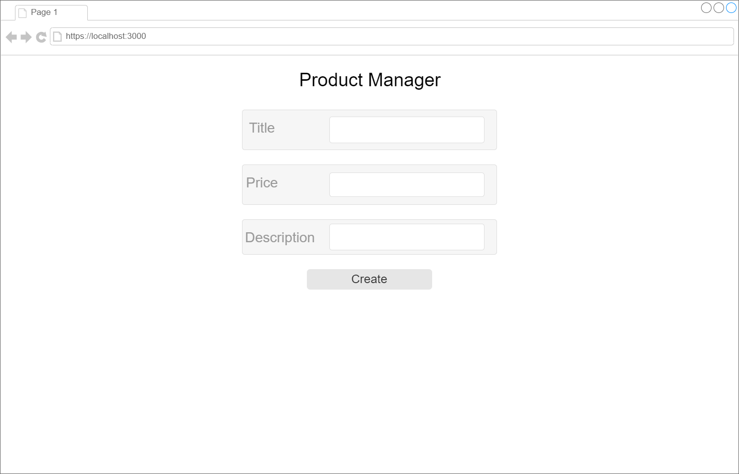

Note: We will be using this project for the next couple of assignments as well, so keep that in mind as you are building it.

In this assignment, you will add the ability to create a new product on the main page of the app.

* Top of Form
  + Create your MERN stack folder structure
  + Create your server, model, controller, routes, and config files for your server
  + On the client end ==> Create a form component so that your Product can have a title, price and description
  + Check in your database that your products are being added

Bottom of Form